How to Restore the PAX Ribbon in Excel
  - John Vaughan, October 2018

What is Planning Analytics for Excel (PAX)?
PAX is the Excel add-in that provides access to TM1 cubes. With it you can do ad hoc exploration, create quick reports, create unlimited length reports and highly customised reports. It replaces the old TM1 Perspectives add-in.

What are the PAX Add-ins?
PAX connects to the Planning Analytics Workspace (PAW) server (not the TM1 server). To do this it uses Excel Add-ins.
There are actually three add-ins that need to be active in Excel for PAX. Two are regular Excel Add-ins and one is a COM Add-in.
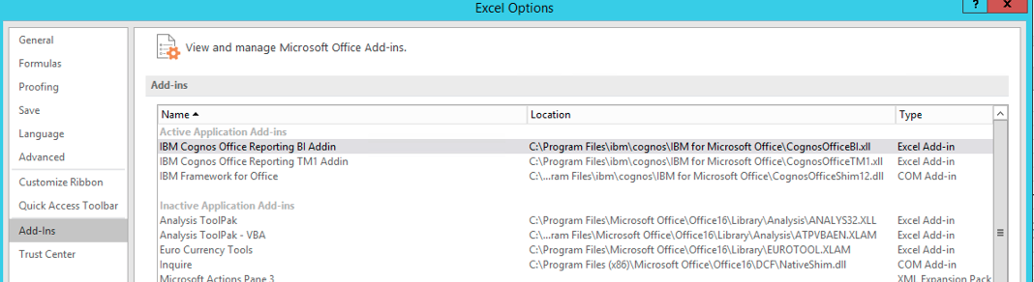
When these are present, PAX will behave properly, and the PAX ribbon will be visible in Excel like this:
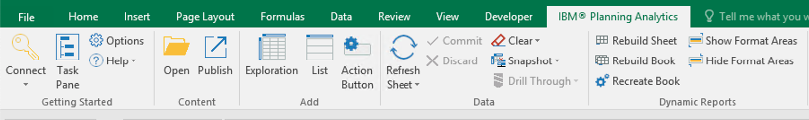

Problems with the PAX Ribbon or PAX Behaviour
If PAX is not behaving properly, you might need to go to File, Options, Add-ins and re-enable either the Excel Add-ins or COM Add-in.
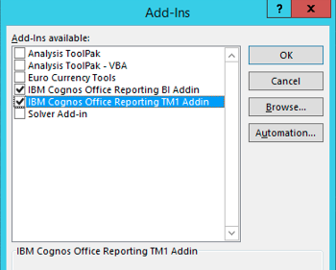
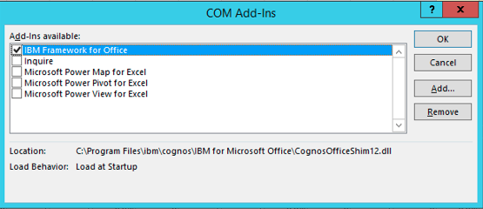
Note that these MUST point to the correct installation location for PAX (yes, do check it because we have seen multiple installation of PAX – 32 bit, 64 bit, C drive and E drive all on the one computer!).
Then, if the PAX Ribbon does not load when Excel is opened, do the following:
- Exit from Excel
- Open the Registry Editor
- Find each instance of “CognosOffice12.Connect” and check the setting on the LoadBehavior property. It must be set as a “3”, like this:
- 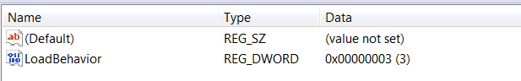
- If it is not a 3, edit and make it a 3.
- Then find the next instance of CognosOffice12.Connect and repeat so that all LoadBehavior properties are a 3.
- Exit from the Registry Editor
- Start Excel
You should now have the PAX ribbon visible.

